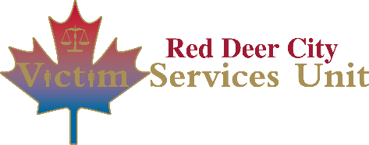
Victim Policy & Procedures
Direct Referrals
When a client is interested in making contact with an agency for services, the only agencies we will make direct referrals to are:
- Central Alberta Sexual Assault Centre
- Red Cross
In order to make a Direct Referral we must obtain the Client’s permission to make the referral and this should be document in the Notes in VSCM.
Once permission is obtained, the follow process applies:
- Record in VSCM permission to Direct Refer, and to which organization
- Red Cross:
  - Call Red Cross Mobilization 1-888-800-6493
  - Document in VSCM
- CASAC:
  - Call CASAC and ask to provide a referral 403-340-1124
  - If it is after hours VSU staff will make the referral the next business day; create a Message/Question task in VSCM
    - Task Type: Message/Question
    - Action Type: Other
    - Description: Direct referral required - CASAC.

